**TSA Flying Pig Café Prices**

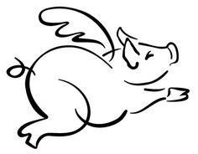

Full Breakfast\**…………………………………………………………………………….…………$*2.00

Breakfast Entrée………………………………………………………………….……….….…..$1.25

Yogurt ………………………………………………………………………………………………………$0.75

Juice………………………………………………………………………………………………………….$0.60

Full Lunch*…………………………………………………….…….…………………………$3.50 (Adult $5.50)

Entrée…………………….…………………………………………………………………………………$2.00

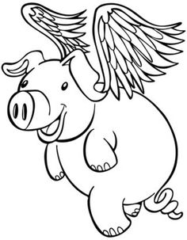

Side Salad…………………………………………………………………………………….………….$2.00

Hummus & Veggies or Pita……………………………………………………………...……$2.00

Extra salad topping or dressing………………………………………………………….$0.50

Pizza Slice………………………………………………………………………….…………………….$2.00

Bread………………………………………………………………………………..…………..………….$0.75

Side of Fruit or Vegetable………………………....……………………………………...$0.75

Extra Cookie……………………………………………………………………………………………$0.55

Milk………………………………………………………………………………………………..………….$0.60

Water…………………………………………………………..………………………..…………………$0.75

*A full breakfast consists of an entrée, juice or fruit and milk.

*A full lunch consists of an entrée, vegetables, fruit and choice of milk or water.

Ice Cream Prices:

Cup…………………………………………………………………………………………………………………………..$1.50

Bar…………………………………………………………………………………………………………………………..$2.25

Cone…………………………………………………………………………………………………………………………$2.75