TSA Flying Pig Café Prices
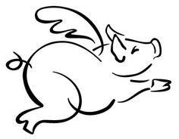

Full Breakfast*…………………………………………………………………………….…………$1.85
Breakfast Entrée………………………………………………………………….……….….…..$1.00
Yogurt or Granola Bar……………………………………………………………………………$0.50
Juice………………………………………………………………………………………………………….$0.40
Full Lunch*…………………………………………………….…….…………………………$3.50 (Adult $4.25)
Entrée…………………….…………………………………………………………………………………$1.50
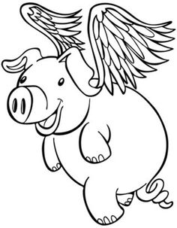
Side Salad…………………………………………………………………………………….………….$1.75
Hummus & Veggies or Pita……………………………………………………………...……$1.50
Extra salad topping or dressing………………………………………………………….$0.30
Pizza Slice………………………………………………………………………….…………………….$1.50
Bread or Roll………………………………………………………………………………..………….$0.30
Side of Fruit or Vegetable………………………....……………………………………...$0.50
Extra Cookie……………………………………………………………………………………………$0.30
Milk………………………………………………………………………………………………..………….$0.45
Water…………………………………………………………..………………………..…………………$0.50
*A full breakfast consists of an entrée, juice or fruit and milk.
*A full lunch consists of an entrée, vegetables, fruit and choice of milk or water.
Ice Cream Prices:
Cup…………………………………………………………………………………………………………………………..$1.00
Bar…………………………………………………………………………………………………………………………..$1.50
Cone…………………………………………………………………………………………………………………………$2.00

